**REACT JS**

React is developed by the Facebook.

React will work on two methods which are Class Based and Functional Based.

React is Very helpful to create SPA (Single Page Applications) by using the JavaScript Libraries.

React Creates the Virtual Dom in Memory

**Components**

Components is a nothing a particular piece of code which can be reusable in the project.  
Components are two types which are class component and functional component.

Examples for the functional components

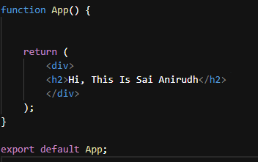

Here we can create multiple components  
  
**Nested Component**

In nested components, multiple functions are defined within a single file. These functions are then utilized within another function or component.

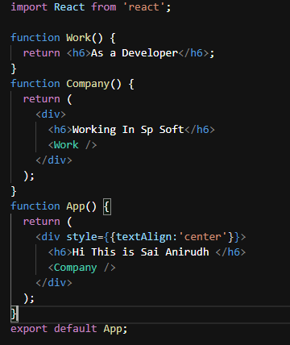

**Stateless Functional Component**

In a stateless functional component, we cannot manage internal state, but we can access data passed down from parent components through props.

const Number = ({ count }) => {

return <h2>The Count is {count}</h2>;

};

**State full Functional Component**

In a state full functional component, we can declare the state values and we can store and handle the state values

import React, { useState } from 'react';

const Counter = () => {

const [count, setCount] = useState(0);

const incrementCount = () => {

setCount(prevCount => prevCount + 1);

};

const decrementCount = () => {

setCount(prevCount => prevCount - 1);

};

return (

<div>

<h2>Counter</h2>

<p>Count: {count}</p>

<button onClick={incrementCount}>Increment</button>

<button onClick={decrementCount}>Decrement</button>

<Number count={count} />

</div>

);

};

export default Counter;

**Higher Order Component**

HOC is function that takes a component as an input and returns a new component with additional functionality.

Here I am taking that validation for login

HOC.Jsx

import React from 'react';

function HOC(Component) {

return class extends React.Component {

render() {

const { auth } = this.props;

if (auth) {

return <div>Please login</div>;

}

return (

<div>

<Component name='Anirudh' />

</div>

);

}

};

}

export default HOC;

in here if the auth is false its return please login if it the auth is true it returns as   
Hi Welcome Anirudh here I am send my name through props

App.jsx

import React from 'react'

import HOC from './hoc'

function App(props) {

return (

<div>

<h1>Hi Welcome {props.name}</h1>

</div>

)

}

export default HOC(App)